1. Create one vpc in N.virginia region.

**Created Autoscaling-vpc CIDR :192.168.0.0/24**

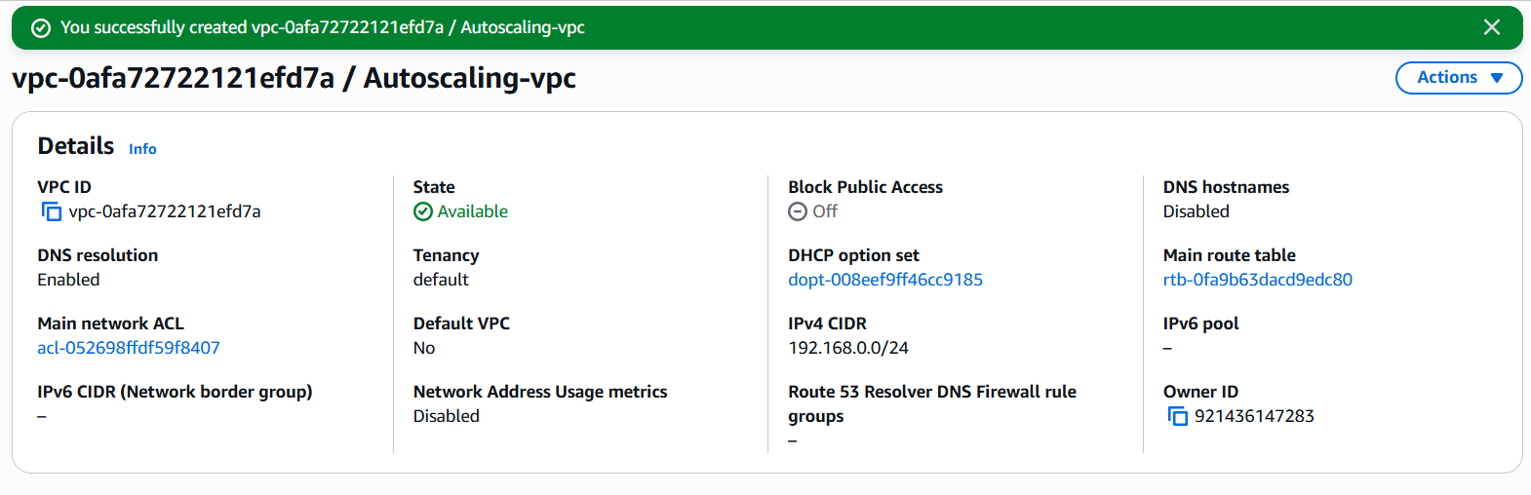  
2) Create two subnets.  
  One Public subnet and one private subnet.

**Created one public-subnet & one private subnet** **using Above VPC**

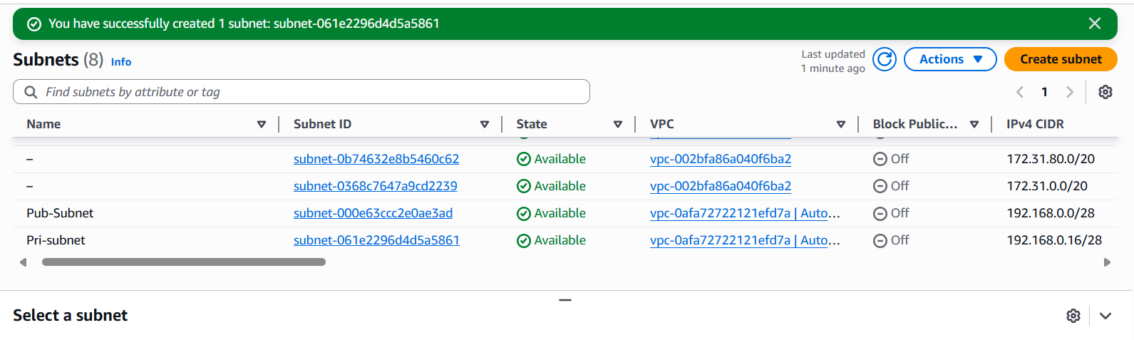  
3) Provide the IGW to the vpc.

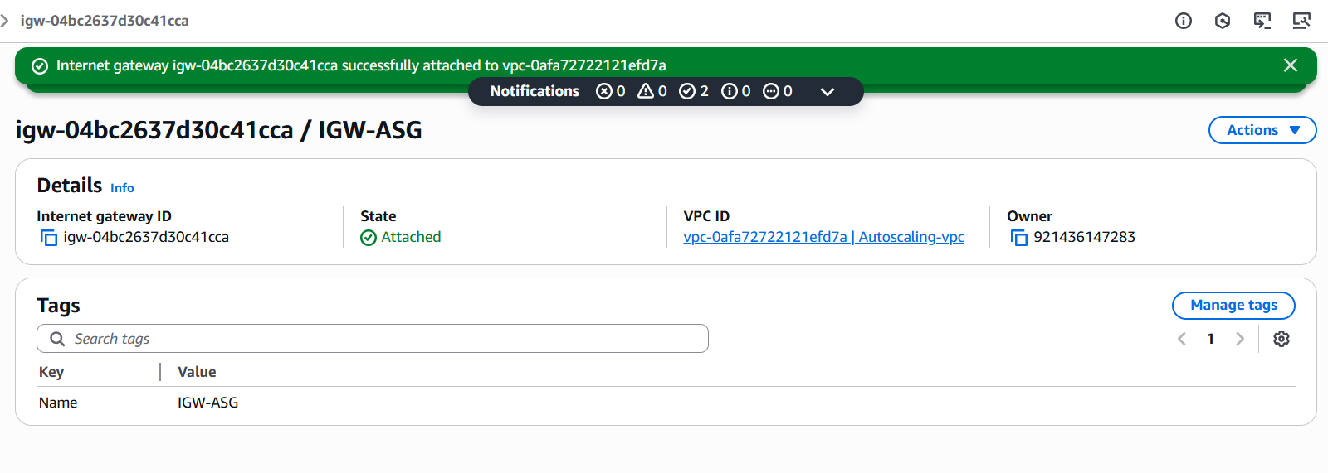  
4) Create One public RT and one private RT.

**PUBLIC ROUTE TABLE**

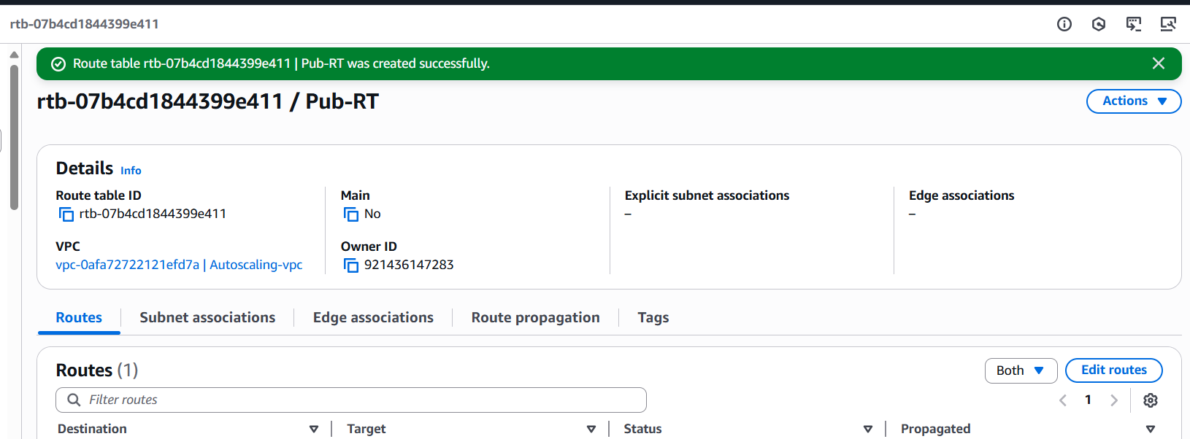

**PRIVATE ROUTE TABLE**

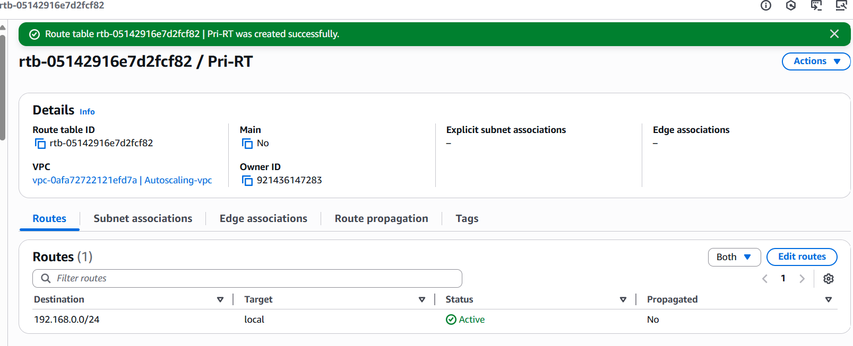

5) Deploy NAT gateway on public subnet and attach the NAT gatewat to private subnet.

**Deployed NAT gateway on public subnet**

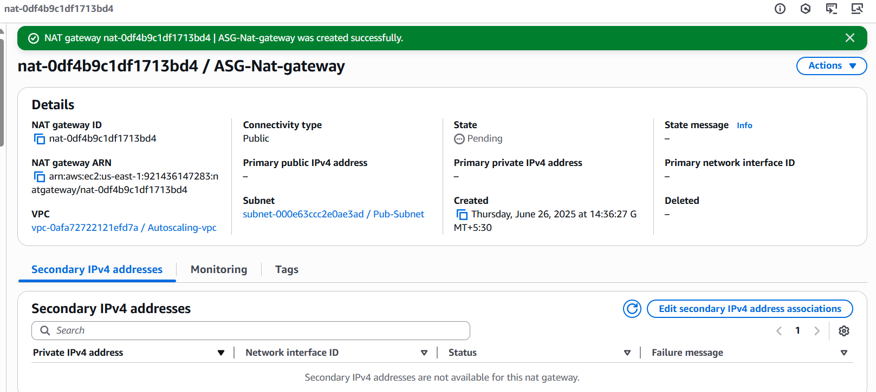

**Attached the NAT gatewat to private subnet**

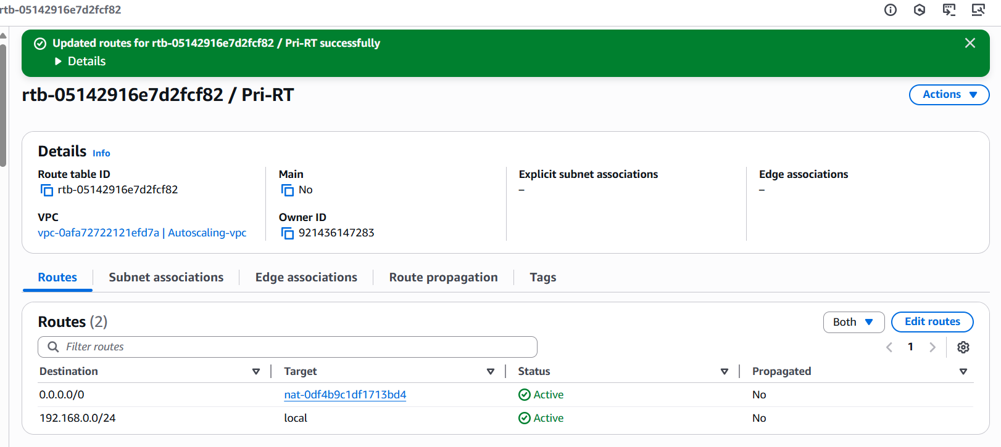  
6) Create Two instances,one in public subnet and one in private subnet.

**Create two instances**

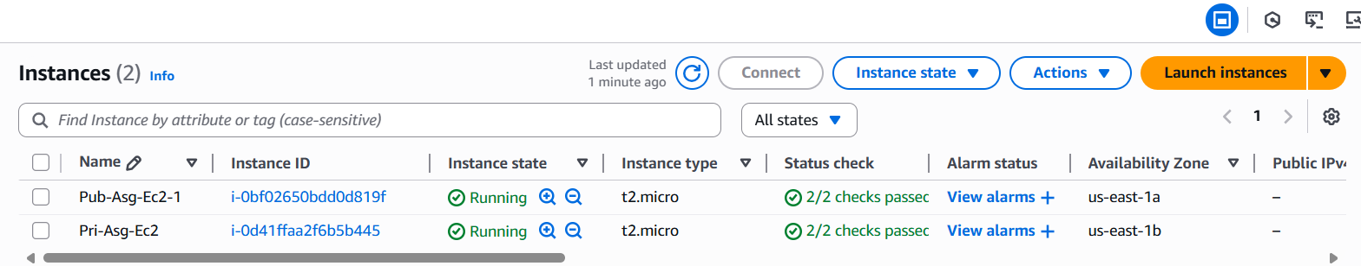  
7) Deploy Apache server on both the ec2 instances with sample index.html file.

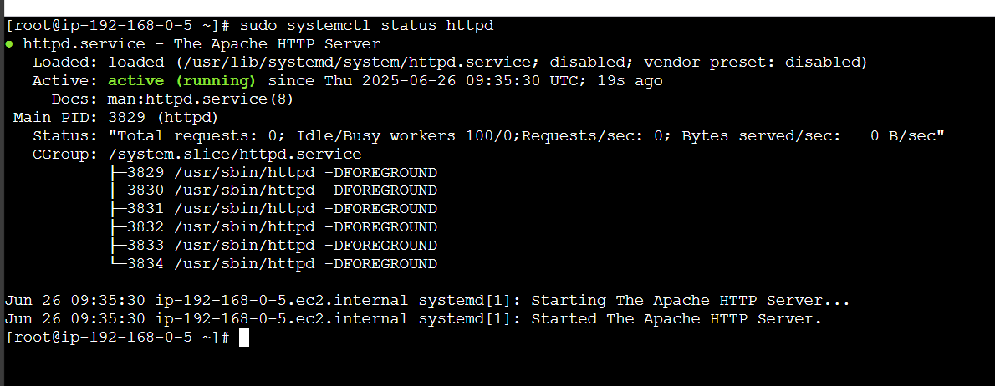 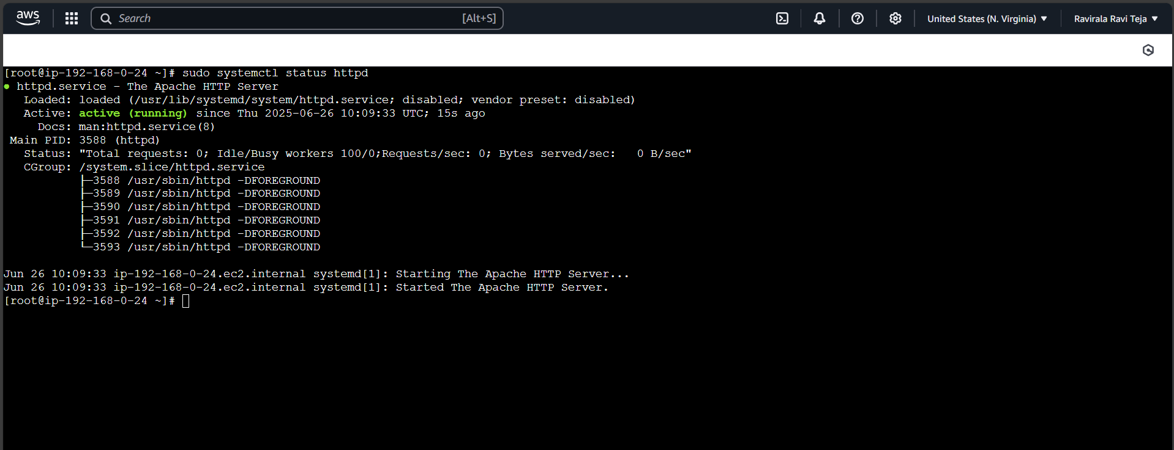  
8) Create one application load balancer and attach the load balancer to both the ec2 instances.

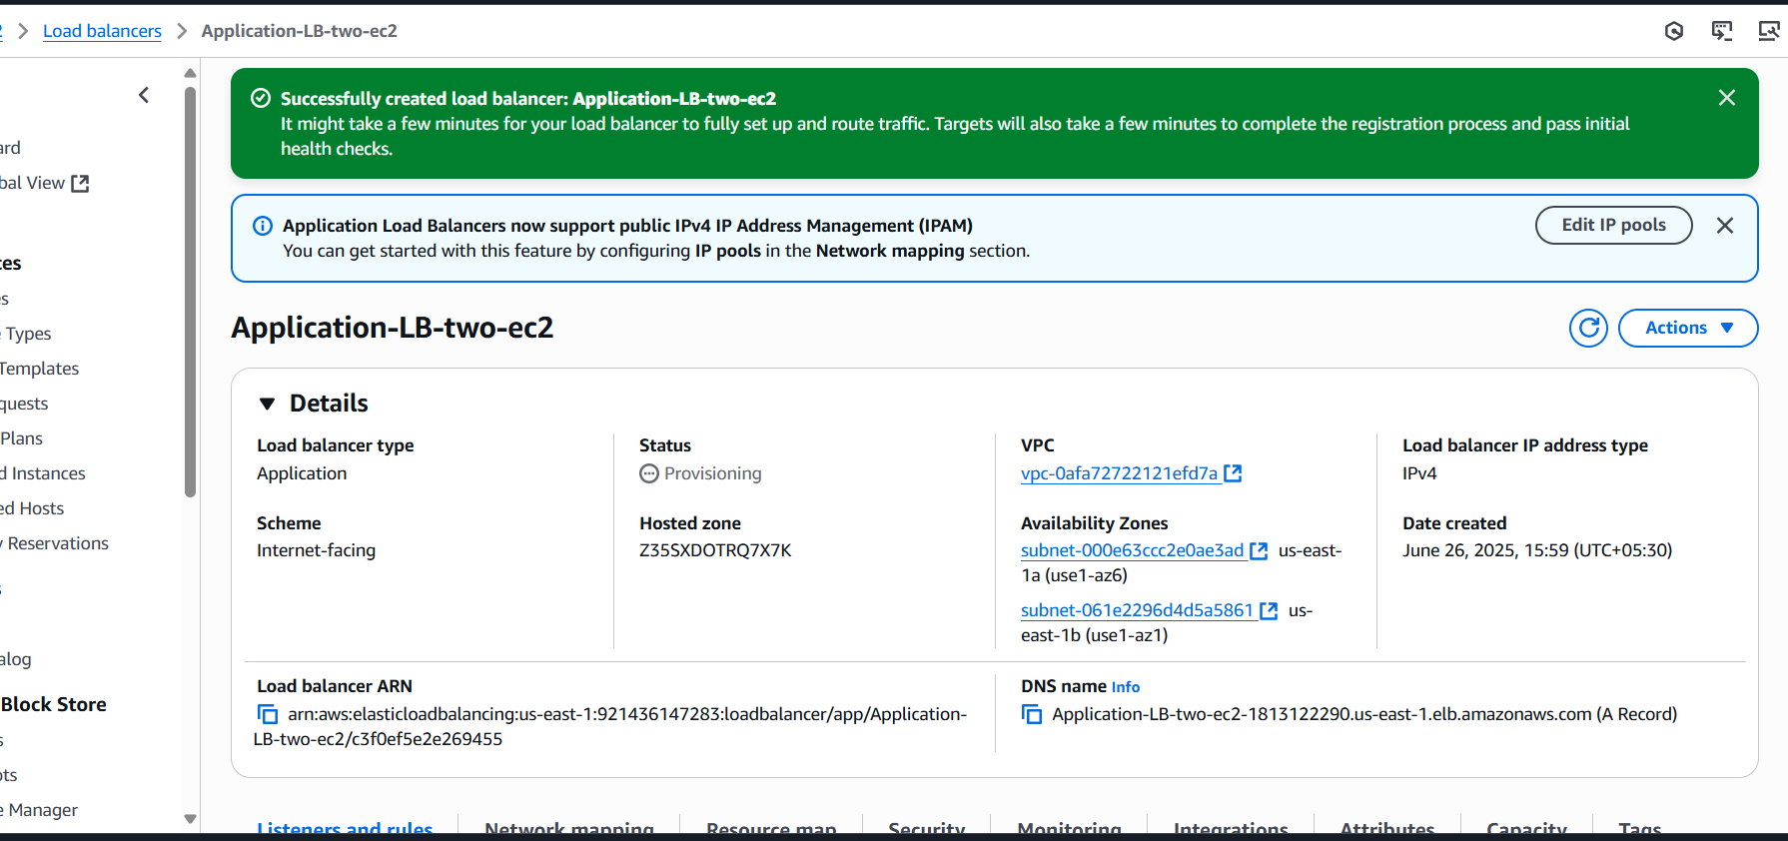

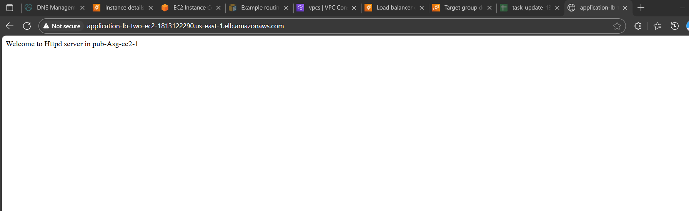 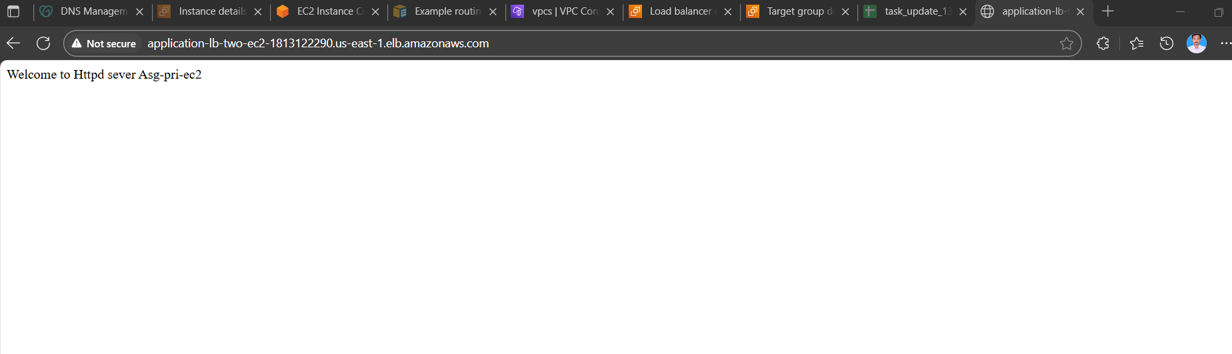  
9) Store Application load balancer logs to s3.

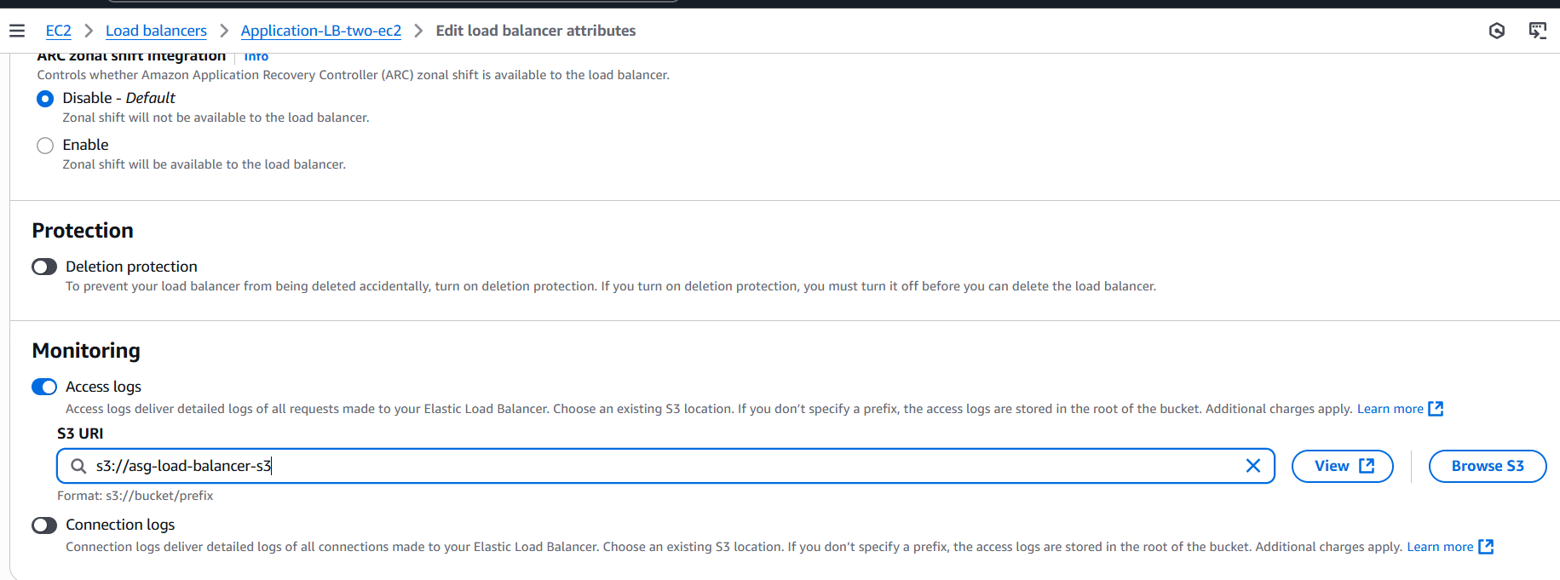 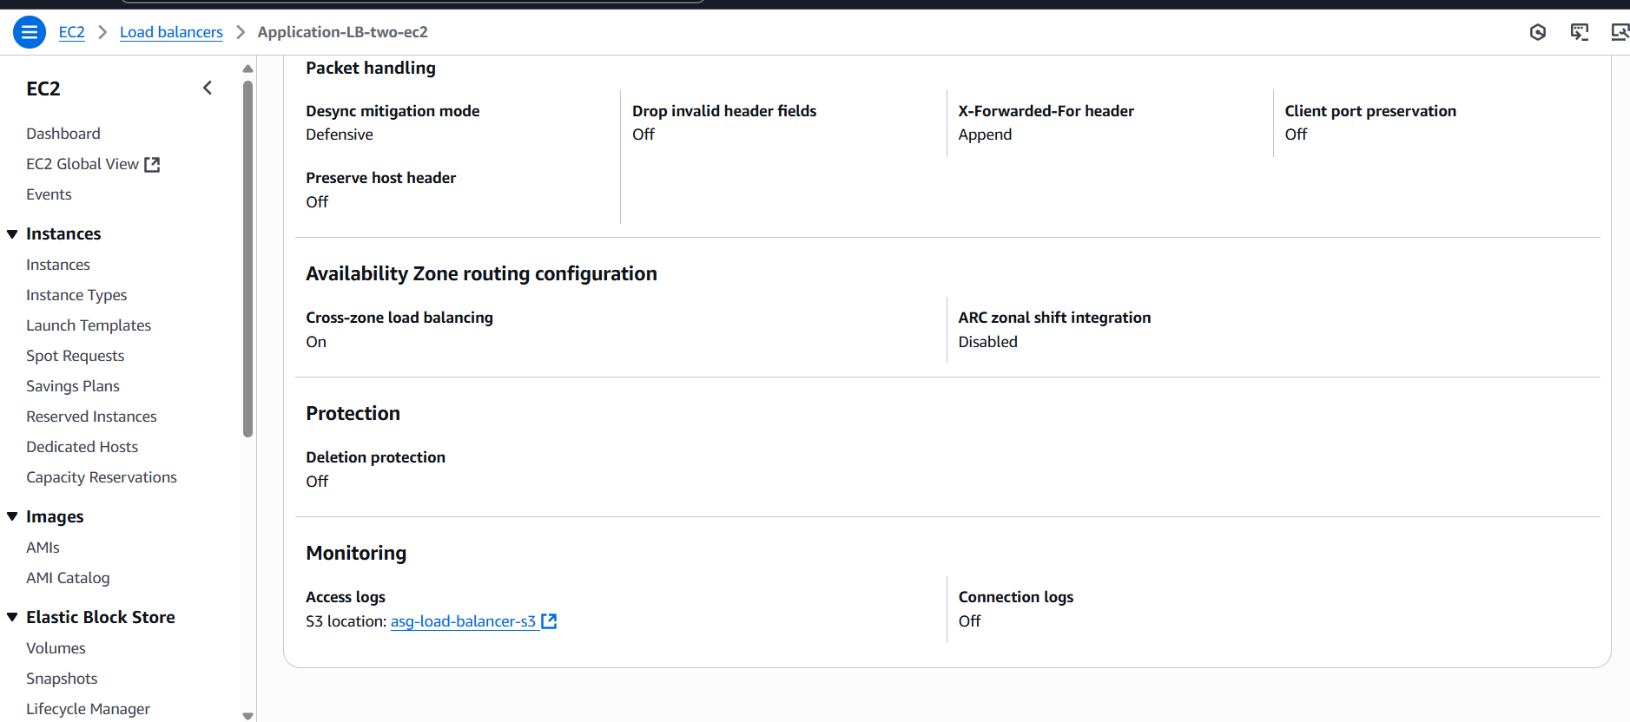

10) Store the vpc flow logs to cloudwtach group.

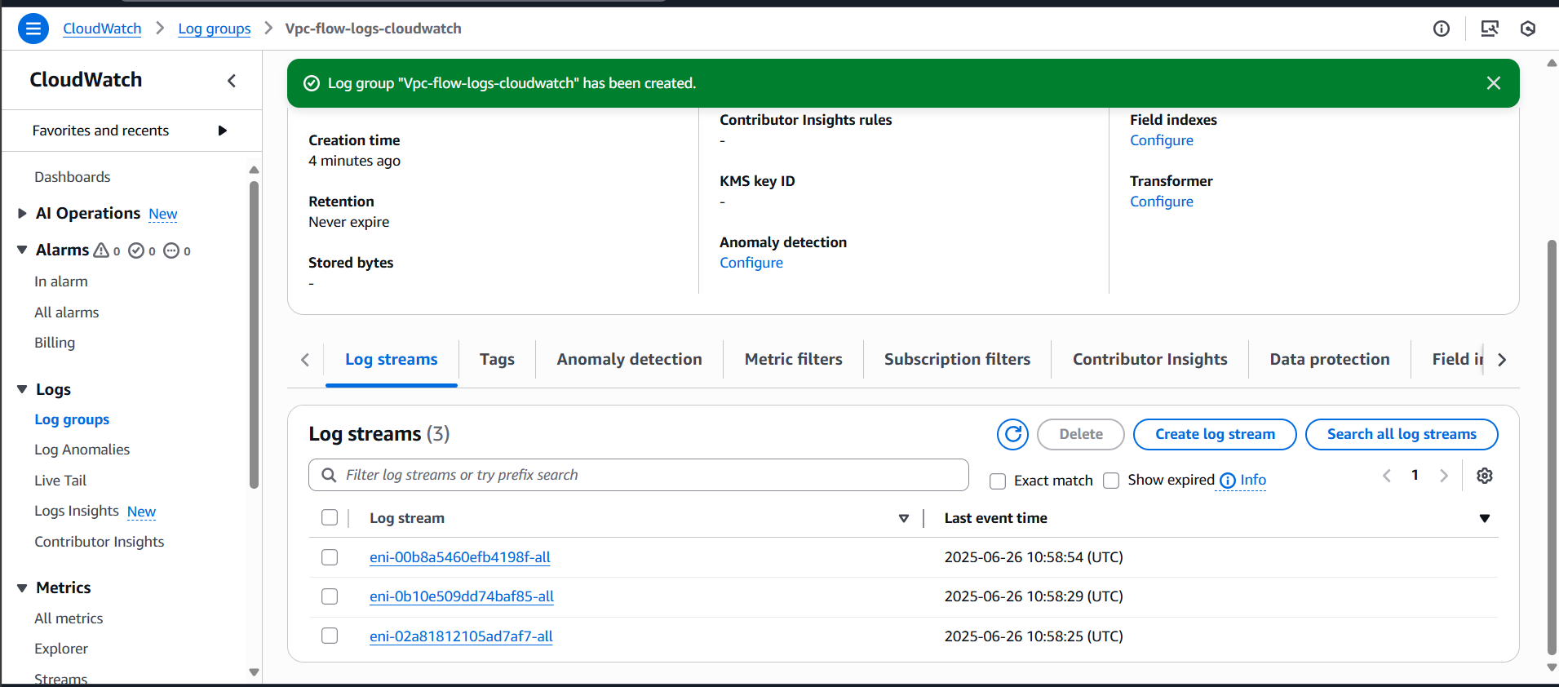  
11) Create Monitoring Dashboards to monitor cpu utilization and to monitor apache service.

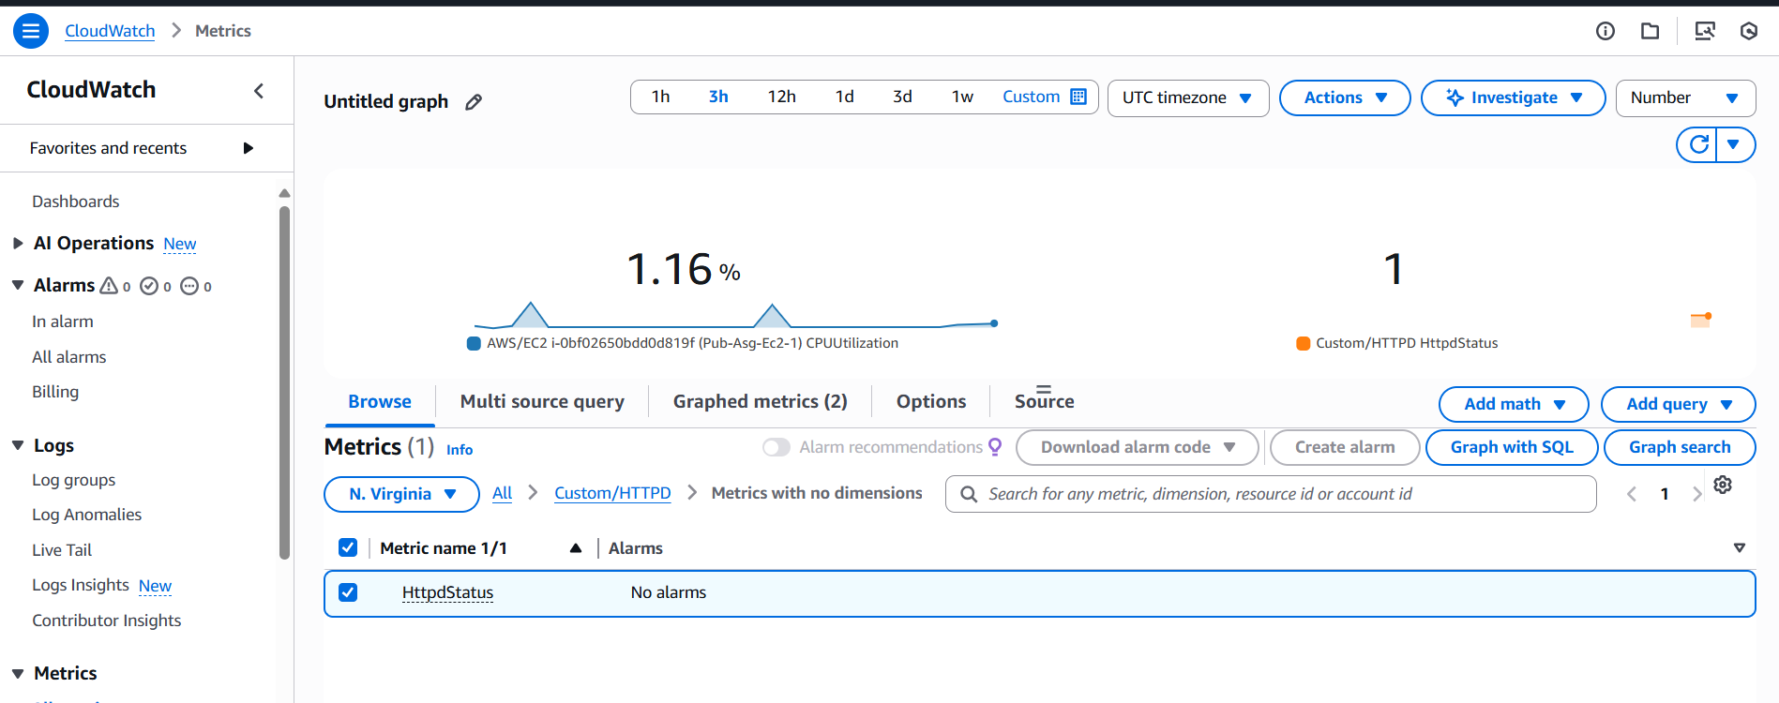  
12) CPU utilizationis more than 70% then it should triggere Autoscaling and launch new instance

